Software Requirements Specification
for
School Admission One-Stop
Version 1.0 approved
Prepared by
Lin Zixing
Terrence Ong
Fabian Wong
Russel Wong

12 November 2021
Table of Contents
Table of Contents ii
Revision History ii
1. Introduction 1
1.1 Purpose 1
1.2 Document Conventions 1
1.3 Intended Audience and Reading Suggestions 1
1.4 Product Scope 1
1.5 References 2
2. Overall Description 2
2.1 Product Perspective 2
2.2 Product Functions 3
2.3 User Classes and Characteristics 3
2.4 Operating Environment 4
2.5 Design and Implementation Constraints 4
2.6 User Documentation 4
2.7 Assumptions and Dependencies 5
3. External Interface Requirements 5
3.1 User Interfaces 5
3.2 Hardware Interfaces 5
3.3 Software Interfaces 5
3.4 Communications Interfaces 5
4. System Features 6
4.1 F01 Category Selection 6
4.2 F02 Information Display 7
4.3 F03 Filter Search 9
4.4 F04 Search 10
5. Other Nonfunctional Requirements 10
5.1 Performance Requirements 10
5.2 Usability Requirements 11
5.3 Security Requirements 11
5.4 Scalability 11
6. Other Requirements 11
Appendix A: Glossary 11
Appendix B: Analysis Models 11

Revision History
Name | Date | Reason For Changes | Version
Lin Zixing | 15/09/21 | Completed draft Section 4 and 5 | 0.1
Lin Zixing | 12/10/21 | Completed draft Section 1 and 2 | 0.2
Lin Zixing | 1/11/21 | Finished first complete draft of SRS | 0.9
Lin Zixing | 5/11/21 | Minor edits and formatting issues | 0.91
Lin Zixing | 14/11/21 | Final revision for SRS | 1.0

Introduction

Purpose
The purpose of this document is to build a mobile application “School Admission One-Stop” to provide consolidated information to students looking to further studies. This application is done as a submission to the fourth Data-Driven Smart Nation Competition as part of the Smart Nation Movement.

Document Conventions
This document uses the following conventions:
ITE | Institute of Technical Education
JC | Junior College
GPA | Grade Point Average
CCA | Co-curriculum Activities
NTU | Nanyang Technological University
CSV | Comma Separated Values
OS | Operating System

Intended Audience and Reading Suggestions
This project is a prototype for the “School Admission One-Stop” application and it is restricted within the premises of Nanyang Technological University. This has been implemented under the guidance of university professors. This documentation is intended to be useful for developers of the application, project managers and other document writers for the application. Developers and document writers can refer closely to the System Features section of this document for reference to the specifications, functional and non-functional requirements of this application.

Product Scope
The purpose of the “School Admission One-Stop” application is to provide a consolidated platform for all necessary and relevant information for a student seeking further education. It aims to provide information found across various institution website all within one application for the convenience of students to compare various institutions and the courses provided.

References
Template for SRS: http://www.frontiernet.net/~kwiegers/process_assets/srs_template.doc
Dataset: Data.gov.sg

Overall Description

Product Perspective
The ”School Admission One-Stop” is a new self-contained application without external components. All data and information are stored within the application itself, in the form of CSV files.

A simplified diagram of the architecture is as shown in the figure below:
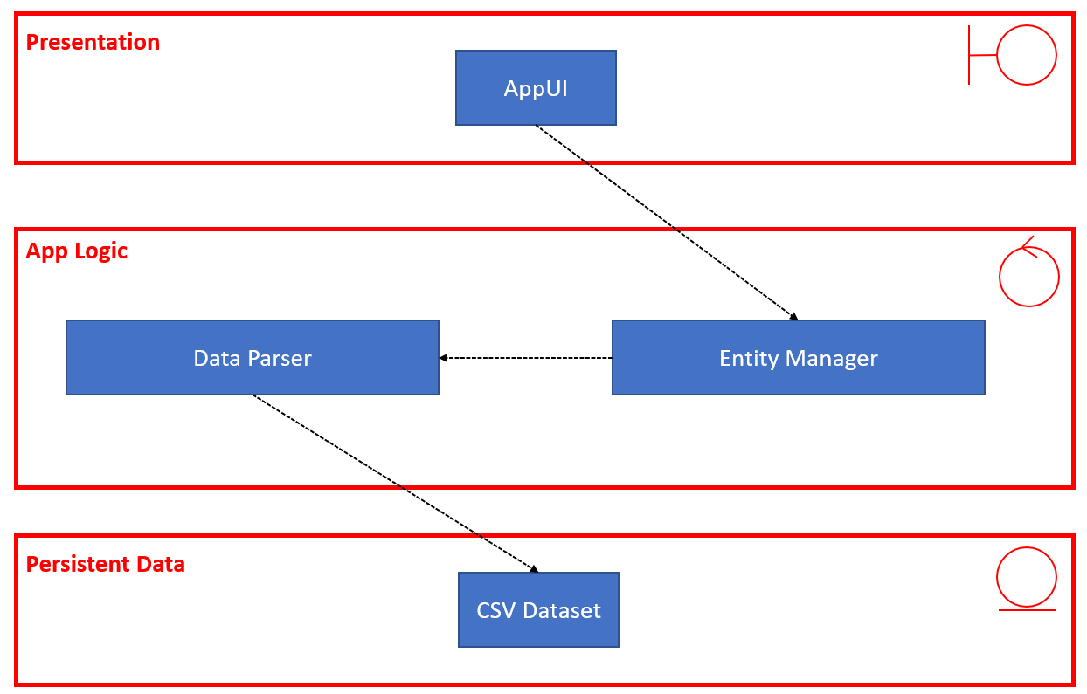

Product Functions
The application aims to provide the following information should the user seek it:
- Institute Information:
This information includes entry requirements, various faculty and schools, co-curriculum activities and other information that would be beneficial to aid the student in making an informed decision regarding the choice of institutes.
- Course Information:
This information includes entry requirements and more detailed information regarding a particular course in a tertiary institute that would be beneficial to aid the student in making an informed decision regarding the choice of institutes.

The user can also use the search functions to customize results for the student based on their results and preferred fields of study, which aims to provide the most suitable courses or institutes for the student.

User Classes and Characteristics
The user class to use the application are prospect students for post-secondary education, and post A-Level or diploma students. The application does not impose restrictions on content accessible, hence all functions are available to every user.

For prospect post-secondary students, the functions that would be more applicable to them would be accessing information pertaining to Junior College, Polytechnic and ITE, as well as the search function.

For prospect post A-Level or diploma students, the functions that would be more applicable to them would be accessing information pertaining to Universities, as well as the search and filter search function.

Details on the functions are available in Section 4. System Features.

Operating Environment
Operating Environment for “School Admission One-Stop” is listed below:
- Hardware: Android device
- Operating System: Android Nougat 7.0 and above

Design and Implementation Constraints
The first constraint is compatibility with android interfaces. The diversity of android device models with variety in specifications creates a challenge to provide compatibility of our application onto each type of device.

The second constraint is to efficiently extract and read data from datasets. Information on various institutes and courses are scattered across the internet. Being able to effectively compile and consolidate this information can prove to be a challenge. Upon consolidation, it can also be a challenge to identify the most efficient way to read this information. The initial plan was to read these data via csv files; however, this may not necessarily be a sustainable way and it could hamper future scalability of our software.

In the future if the software were to be improve, a different approach may be considered to make the operations more efficient, and more compatible with multiple devices. Architecture and tools used can be changed to provide a better application experience.

User Documentation
A video demo will be provided for users to provide information on how to use the functions of the application. Every task and functionality of the application would be showcased within the demo, which allow users to follow the actions taken to access desired functions. The video will be accessible on the download page of the application.

Assumptions and Dependencies
The primary assumption and dependency for this application focuses on the validity and availability of data. As an application to consolidate and provide information, the back end heavily depends on the validity of the information obtainable from various sources, such as data.gov.sg and respective school websites. In the event where data is invalid, users will be provided with the wrong information, which will greatly hamper the reliability and trustworthiness of this application.

Many functionalities of the application also depend on the availability of information. For instance, in order to display CCA information, this information should be initially obtainable, before it can be consolidated and used for the application. However partial information or incomplete information will affect the usefulness of this application.

External Interface Requirements

User Interfaces
Please refer to Appendix B7: UI Mockup.

Hardware Interfaces
The application is expected to run on Android Devices that run the Android OS. The application will be downloadable and will be executed on top of the operating system within the Android Device.

Software Interfaces
The application runs directly on the Android Operating System without the use of external tools or components. It does not communicate with any other software within the device or external of the device. All required information is prepared and stored within CSV files prior to deployment of application. The CSV files are stored within the application and all forms of data retrieval are performed within the application itself.

Communications Interfaces
The application does not possess any form of communication interface or functionalities.

System Features

F01 Category Selection
4.1.1 Description and Priority
The Category Selection is one of the first screens provided to users as a root to all other pages in the application. This feature allows users to select the category of institutes they are interested in, categorized under “Post ‘A’ Level/Diploma” and “Post-Secondary”. This feature is of medium priority as it provides a landing page for users and acts as starting point into the application.

4.1.2 Stimulus/Response Sequences
Stimulus: User selects the “Post ‘A’ Level/Diploma option
Response: System provides the list of Universities.

Stimulus: User selects the “Post-Secondary” Option
Response: System provides another set of category options labelled “Junior College”, “Polytechnic”, and “Institute of Technical Education”.

Stimulus: User selects the “Post-Secondary Option, then selects Junior College.
Response: Systems provides the list of Junior Colleges.

4.1.3 Functional Requirements
F01_01: The system must provide the initial category selection to query the user’s target institution.
- F01_01a: The category selection must include an option for “Post ‘A’ Level/Diploma”.
- F01_01b: The category selection must include an option for “Post-Secondary”.

F01_02: The system must provide a further category selection if “Post-Secondary” is selected
- F01_02a: The further category selection must include an option for “Junior College”.
- F01_02b: The further category selection must include an option for “Polytechnic”.
- F01_02c: The further category selection must include an option for “Institute of Technical Education”.
F01_03: The system must return the list of institutions belonging to selected category or further category.

F02 Information Display
4.2.1 Description and Priority
The information display feature provides users with all necessary information regarding a particular institute or a course in an institute, such as entry requirements, and co-curriculum activities (CCAs). Different types of institutes would provide slightly varied information, as not all information of a type of institute are valid for another. As a core feature, information display is a high priority feature.

4.2.2 Stimulus/Response Sequences
Stimulus: User selects a “Temasek Polytechnic” from list of Polytechnics.
Response: System provides information related to Temasek Polytechnic, including description, list of schools, list of courses and CCAs.

Stimulus: User selects a “Nanyang Junior College” from list of Junior Colleges.
Response: System provides information related to Nanyang Junior College, including description, entry requirements, subjects available and CCAs.

Stimulus: User selects “Diploma in Game Design and Development” in Temasek Polytechnic.
Response: System provides information related to the selected course in the polytechnic, including description and entry requirements.

4.2.3 Functional Requirements
F02_01: The system must provide information of a selected Junior College.
- F02_01a: The system must display the Direct School Admission requirements
- F02_01b: The system must display the cut off points based on previous intake
- F02_01c: The system must display CCAs available.

F02_02: The system must provide information of a selected Polytechnic or Institute of Technical Education.
- F02_02a: The system must display the list of schools
- F02_02b: The system must display the list of courses within the schools
- F02_02c: The system must display CCAs available
- F02_02d: The system must display entry requirements

F02_03: The system must provide information of a selected university
- F02_03b: The system must display the list of colleges and schools
- F02_03c: The system must display the list of courses within the schools
- F02_03e: The system must display entry requirements

F02_04: The system must provide information of selected course in a Polytechnic or Institute of Technical Education
- F02_04a: The system must display the description
- F02_04b: The system must display cut off points based on previous intake

F02_05: The system must provide information of selected course in a University
- F02_04a: The system must display the description
- F02_04b: The system must display entry requirements based on previous intake

F03 Filter Search
4.3.1 Description and Priority
The filter search feature provides users with a series of options to provide a further tailored list of institutes or courses. This is a medium priority feature that will value add to the application.

4.3.2 Stimulus/Response Sequences
Stimulus: User selects filter search as a post ‘A’ level/diploma student
Response: System provides a series of options for users to filter their search

Stimulus: User selects their GPA to be 3.71 in the post ‘A’ level/diploma filter search.
Response: System provides the list of Universities courses with the entry requirements 3.71 GPA and below.

Stimulus: User selects their GPA to be 3.71, preferred university to be NTU, preferred school to be School of Engineering.
Response: Systems provides the list of engineering courses within NTU with the entry requirements of 3.71 GPA and below.

4.3.3 Functional Requirements

F03_01: The system must provide a set of filter options for Universities
- F03_01a: The system must provide an option to input GPA
- F03_01b: The system must provide an option to input preferred universities
- F03_01c: The system must provide an option to input name of course.

F04 Search
4.5.1 Description and Priority
The search feature provides a general keyword matching search function for users. This feature is of low priority.

4.5.2 Stimulus/Response Sequences
Stimulus: User inputs “computer science” in the search bar
Response: System returns all polytechnic, ITE and university courses with the keywords “computer science” it the name

4.5.3 Functional Requirements
F04_01: The system must provide a search bar for user input at the top of the screen when “Search” option is selected
F04_02: The system must match institute and course names with the user input data
- F04_02a: The system must return all matched institutes and courses.

Other Nonfunctional Requirements

Performance Requirements
The application must ensure high performance to attain efficiency for various screen transitions and data retrieval. Specific performance requirements for features are as follows:
Feature Name/ID | Performance Requirements
F01 | The category selection screen transitions for this feature must take less than 0.5s.  Loading of the institute list must take less than 2 seconds.
F03, F04 | The search functions must take less than 2 seconds to return the list of courses/institutions.
F02 | The information features must take less than 1 second to ensure performance.

Usability Requirements
The application must provide an easy-to-use user interface through intuitive button design and universal icons. The application must be easy to learn and allow quick navigation and completion of tasks.

Security Requirements
The application must ensure that all user information are discarded after use, preventing exploitation and misuse.

Scalability
The source codes of the application must be built with the intention to expand the functionalities, such as supporting a greater audience type as well as including foreign institutions.

Other Requirements
Appendix A: Glossary
Please refer to the file titled “AppendixA_Data Dictionary.pdf” which can be found in the same folder as this document.
Appendix B: Analysis Models
B1. Use Case Diagram
Please refer to the file titled “AppendixB1_UseCaseDiagram” which can be found in the same folder as this document.

B2. Use Case Description
Please refer to the file titled “AppendixB2_UseCaseDescription.pdf” which can be found in the same folder as this document.

B3. Class Diagram
Please refer to the file titled “AppendixB3_ClassDiagram.pdf” which can be found in the same folder as this document.

B4. Sequence Diagram
Please refer to the folder titled “AppendixB4_SequenceDiagram” which can be found in the same folder as this document. The sequence diagrams titled “sd Check CCA”, “sd Filter Search”, sd” Intake Requirement”, “sd Search” can be found within this folder.

B5. Dialog Map
Please refer to the file titled “AppendixB5_StateDialogMap.pdf” which can be found in the same folder as this document.

B6. System Architecture
Please refer to the file titled “AppendixB6_SystemArchitecture.pdf” which can be found in the same folder as this document.

B7. UI Mock Up
Please refer to the file titled “AppendixB7_UIMockUp.png” which can be found in the same folder as this document.

